**USER GUIDE TO USE BULK MERGING TOOL**

**Why this tool:**

This tool is used to merge the Invoice and Airway bill together for bulk products.

So that it is easy for fulfilment department to pack the product with Invoice and Airway bill without searching.

Before this tool, they used to search for the Invoice and Airway bill in the bulk data.

**How it works:**

This Bulk merging tool takes a folder of invoices and AWBs as input and produces a pdf file that contains product Invoice first and AWB next and other product’s invoice and AWB and so on in a sorted order.

So that it is easy for fulfilment department to get Invoice and Airway bill together for bulk products.

**How to use it:**

**Step-1:-**Open amazon seller central and select products that we receive the order.

**Step-2:-** Now, view the each product details and copy the tracking ID.

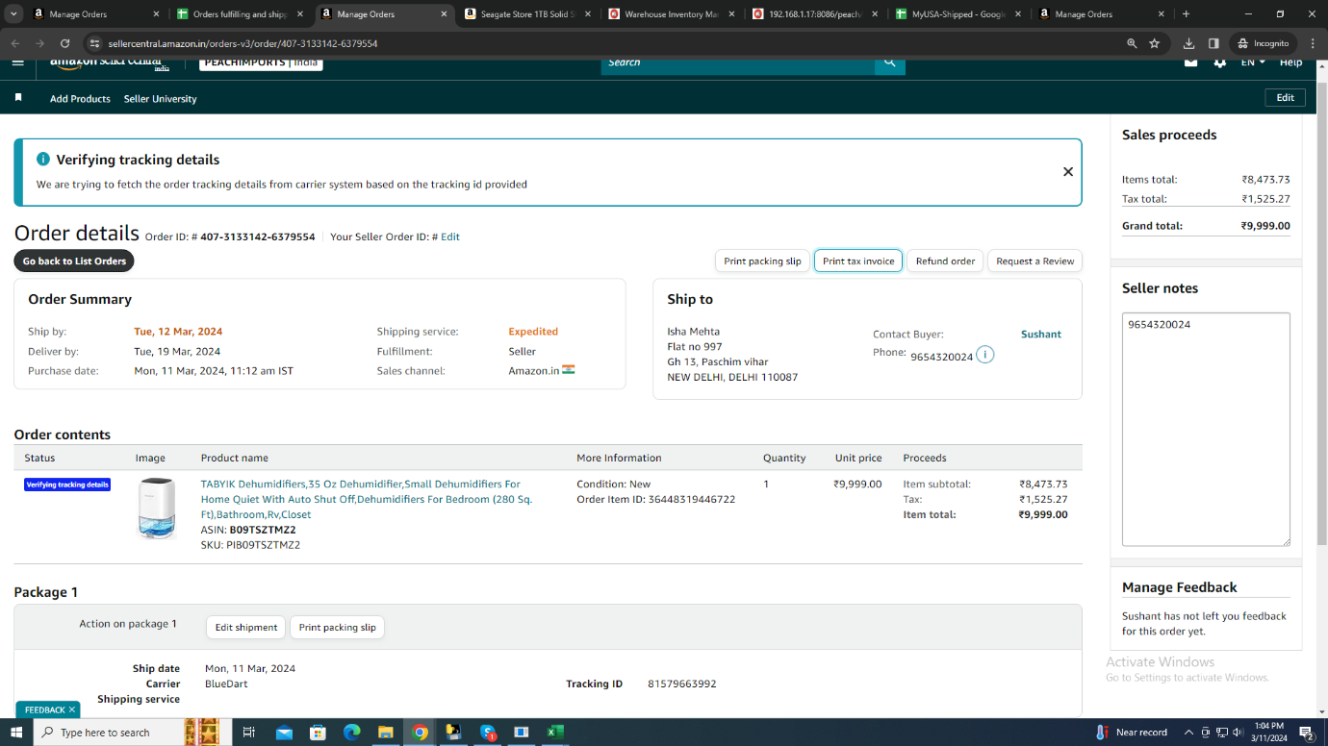

**Step-3:-**Click on the **print tax invoice** button and save the invoice file name as **‘Tracking ID space – space I’** (Eg:**81579366260 – I.pdf**) in pdf format.

**Step-4:-**Now, open BlueDart Air Way Bill(AWB) form and fill the order details manually and save the form file name as tracking ID in pdf format.

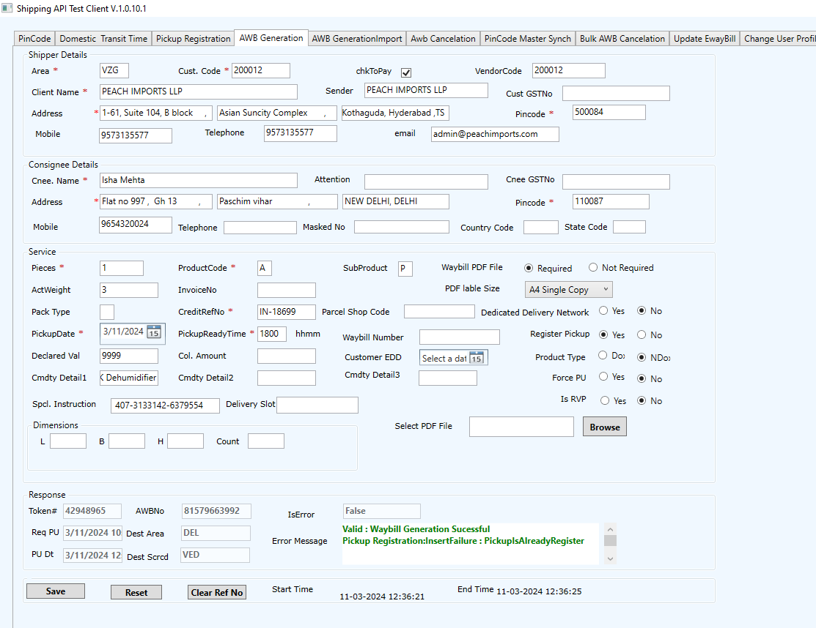

**Step-5:-**Once, you get all the order’s **INVOICE AND AWB** in one folder.

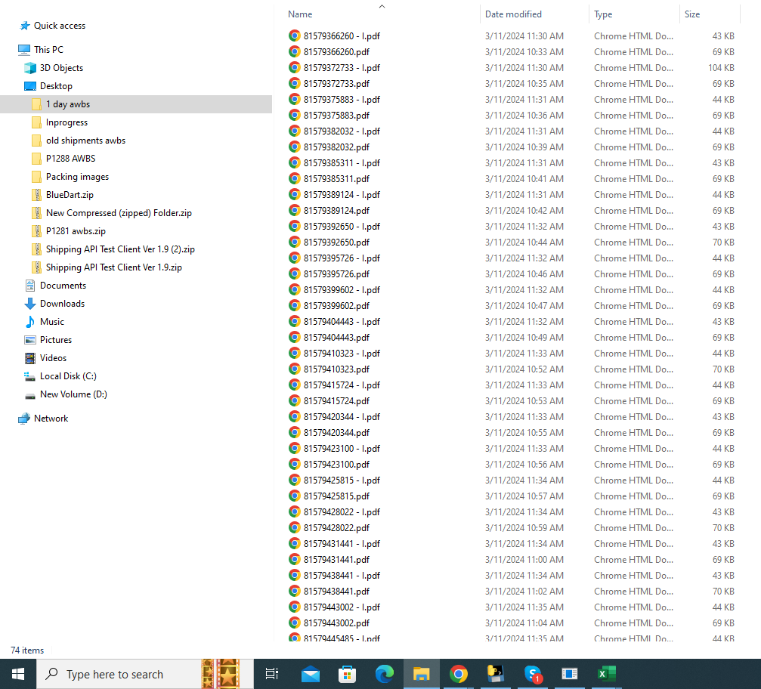

**Step-6:-**Open **Merge Your Bulk Files Into One Tool** and enter your name and upload this Invoice and AWB folder in choose the file field and click upload button

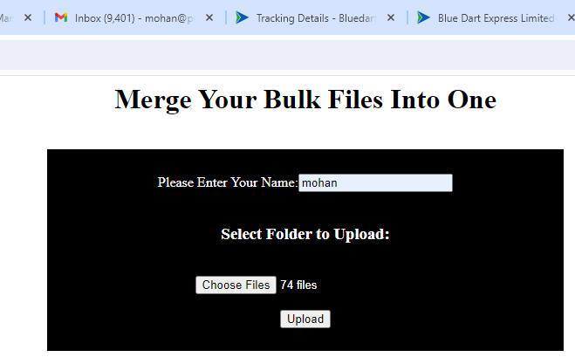

**Step-7:-**After completion of this program, download the file using download report button.

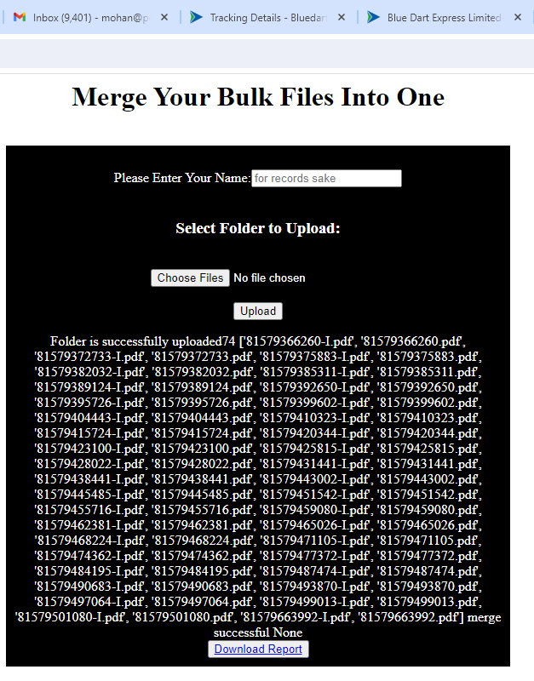

**Step-8:-**Now, Extract this downloaded file and there is a pdf with invoices and AWBs for bulk orders.

**Step-9:-** Send this **Bulk PDF** via Email to Warehouse Department. So that it is easy for them to pack the product with Invoice and AWB.

**Any Updates (If required):**